**OD APPLICATION**

Proof of Registration:

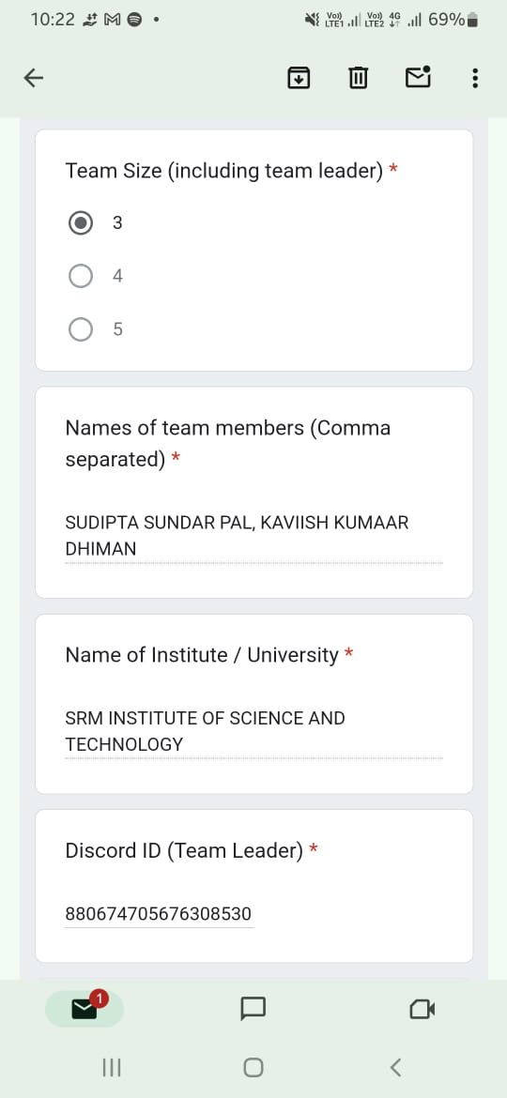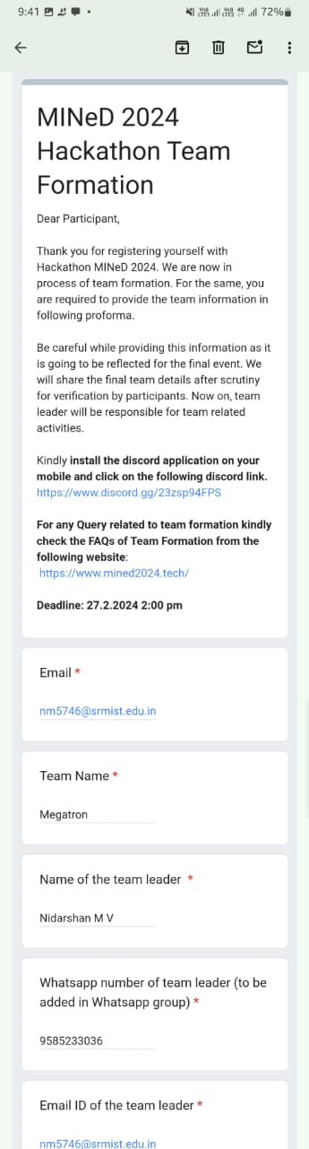

Proof of Acknowledgment:

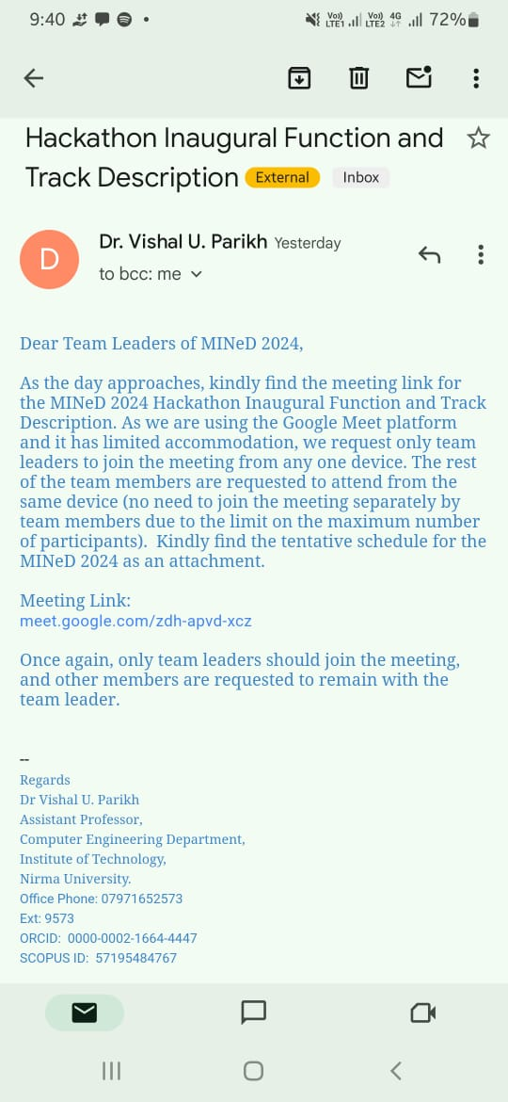

Proof of Participation: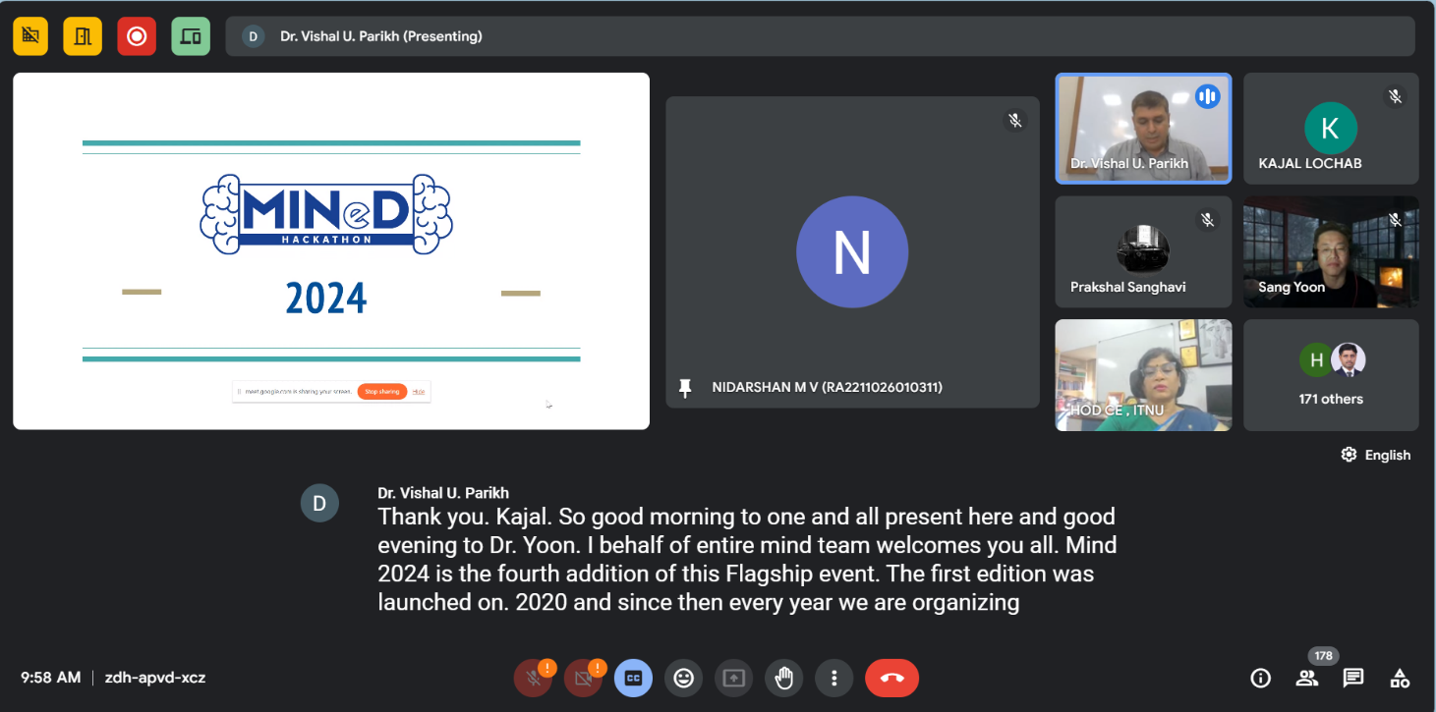

Provided Schedule (by the organizer);



Tentative Schedule

|  |  |
| --- | --- |
| **29th February (Day 1)** | |
| 9.30 AM to 10.30 AM | Inauguration ceremony |
| 10.30 AM to 11.45 AM | Industry sponsors will describe the problem statements. |
| 11:45 AM onwards | Hackathon begins... |
| 11:45 AM to 12.30 PM | Track selection by participating teams and finalising it and submitting final tracks |
| 12.30 PM to 00.00 AM | Hacking continues… |
| **1st March (Day 2)** | |
| 12.01 AM to 00.00 AM Hacking continues... | |
| **2nd March (Day 3)** | |
| 12.01 AM to 11.59 AM | Hacking continues... |
| 12.00 noon | Hackathon ends… |
| 12 noon to 1.00 pm | Final Submission |
| 1.30 pm to 4.30 pm | First round of evaluation begins (Project Presentation of all teams) |
| 4.30 pm to 5.30 pm | Decision and scrutiny of teams for final round |
| 5.30 pm onwards | Final round of evaluation (Project Presentation of top selected teams) |
| 9.30 pm to 10.00 pm | Announcement of Prize Winner,    Concluding Remarks and valedictory session |

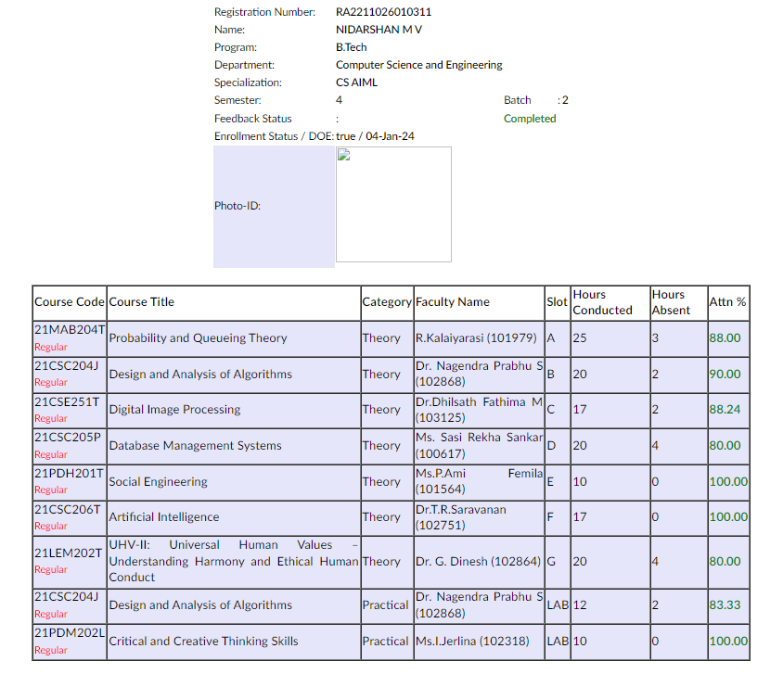Current attendance percentage :